**Integration Testing**

**Integration Test Case**

**URS-01: Customer register to system**

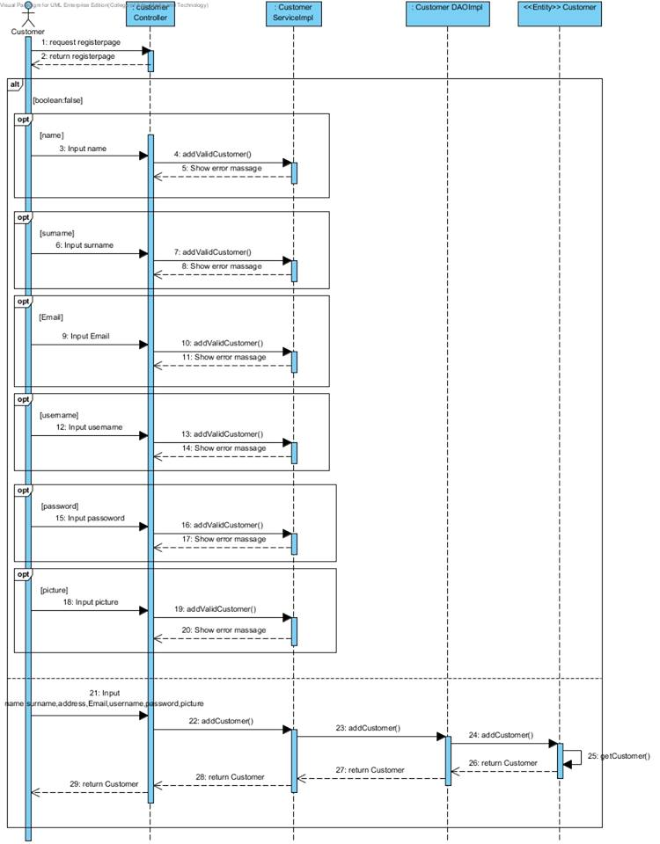

***SD-01: Customer register to system***

**ITC-**

Check the integration between

|  |  |
| --- | --- |
| **Test Case ID** |  |
| **Test Item(s)** |  |
| **Test Description** |  |
| **Expect Output** |  |
| **Actual Output** |  |

**URS-02: Customer login to system**

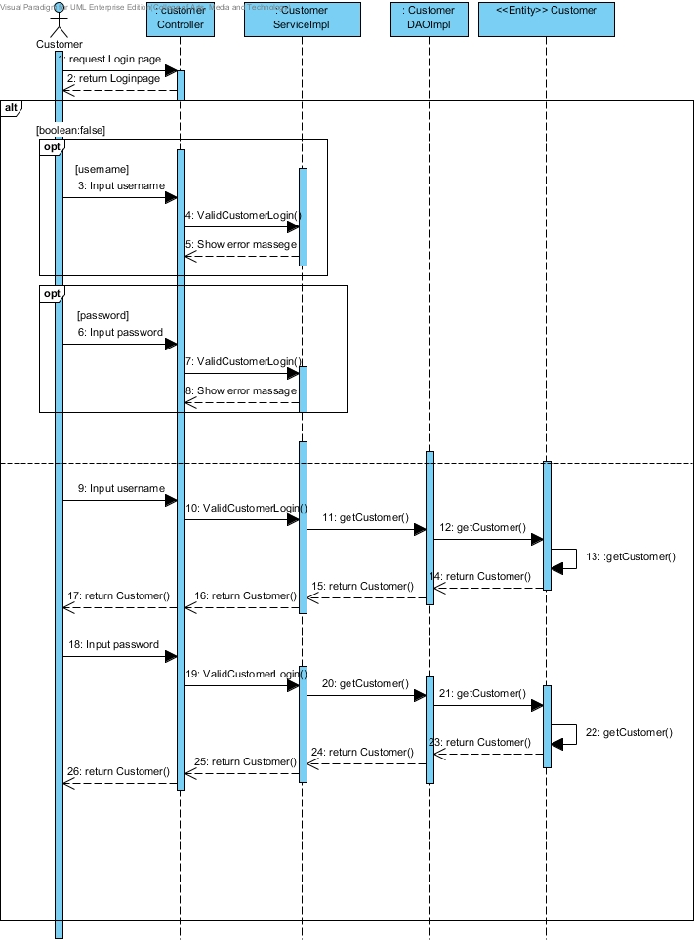

***SD-02: Customer login to system***

**ITC-**

Check the integration between

|  |  |
| --- | --- |
| **Test Case ID** |  |
| **Test Item(s)** |  |
| **Test Description** |  |
| **Expect Output** |  |
| **Actual Output** |  |

**URS-03: Customer update information**

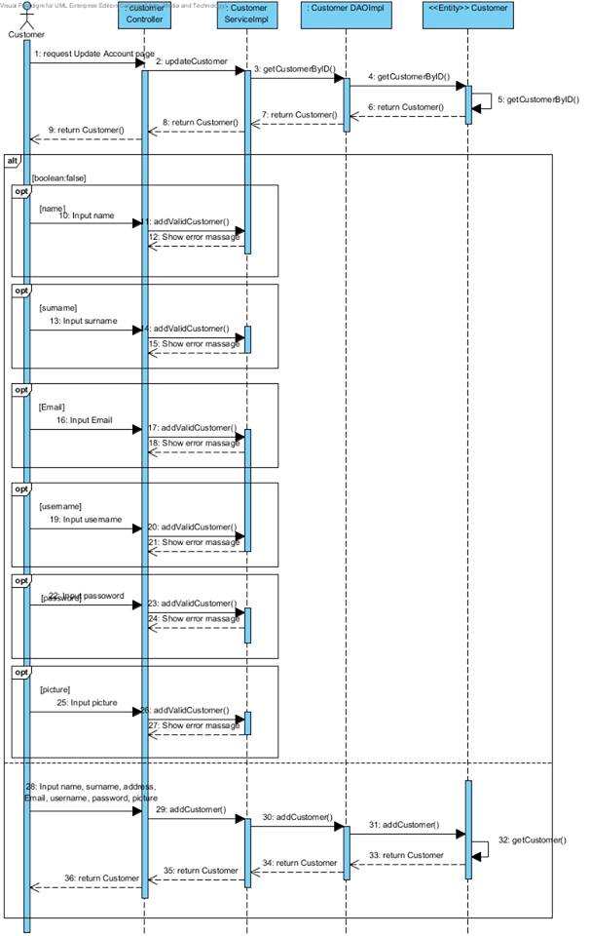

***SD-03: Customer update information***

**ITC-**

Check the integration between

|  |  |
| --- | --- |
| **Test Case ID** |  |
| **Test Item(s)** |  |
| **Test Description** |  |
| **Expect Output** |  |
| **Actual Output** |  |

**URS-03: Customer search product by name**

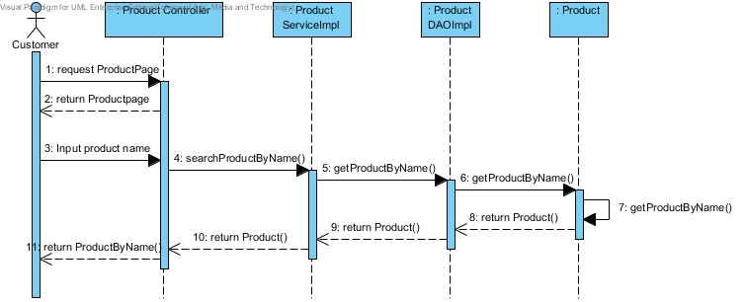

***SD-04: Customer search product by name***

**ITC-**

Check the integration between

|  |  |
| --- | --- |
| **Test Case ID** |  |
| **Test Item(s)** |  |
| **Test Description** |  |
| **Expect Output** |  |
| **Actual Output** |  |

**URS-05: Customer browse product from catalog**

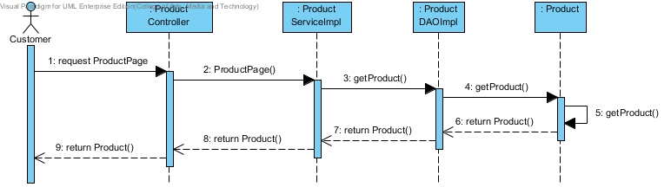

***URS-05: Customer browse product from catalog***

**ITC-**

Check the integration between

|  |  |
| --- | --- |
| **Test Case ID** |  |
| **Test Item(s)** |  |
| **Test Description** |  |
| **Expect Output** |  |
| **Actual Output** |  |

**SD-06: Customer add product to cart**

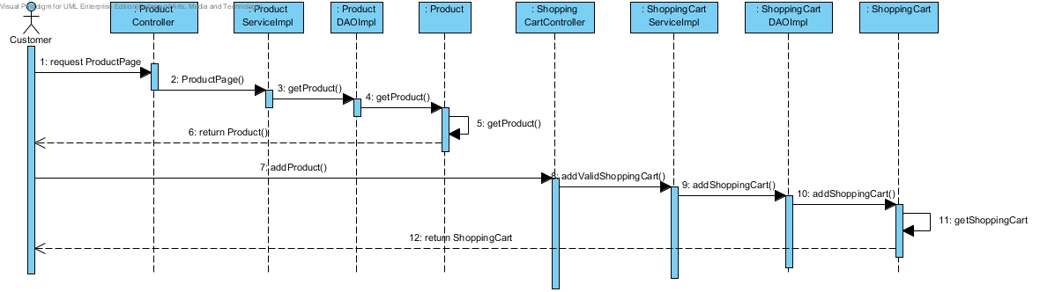

***SD-06: Customer add product to cart***

**ITC-**

Check the integration between

|  |  |
| --- | --- |
| **Test Case ID** |  |
| **Test Item(s)** |  |
| **Test Description** |  |
| **Expect Output** |  |
| **Actual Output** |  |

**URS-07: Customer identify amount of product**

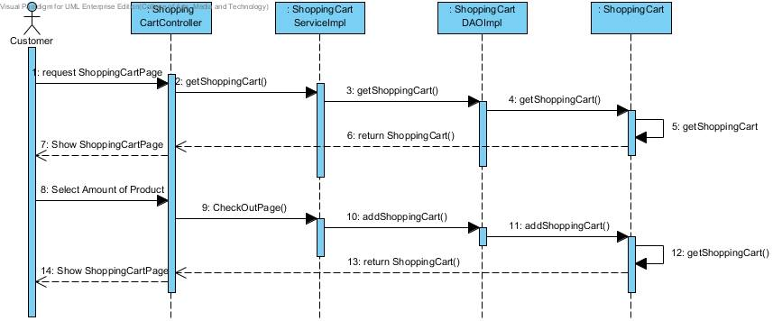

***SD-07: Customer identify amount of product***

**ITC-**

Check the integration between

|  |  |
| --- | --- |
| **Test Case ID** |  |
| **Test Item(s)** |  |
| **Test Description** |  |
| **Expect Output** |  |
| **Actual Output** |  |

**URS-08: Customer can view shopping cart**

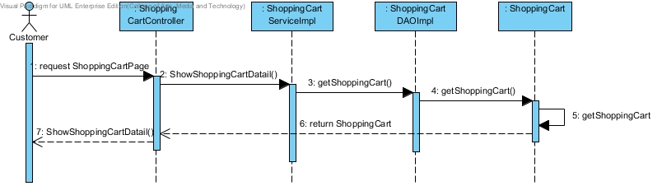

***SD-08: Customer can view shopping cart***

**ITC-**

Check the integration between

|  |  |
| --- | --- |
| **Test Case ID** |  |
| **Test Item(s)** |  |
| **Test Description** |  |
| **Expect Output** |  |
| **Actual Output** |  |

**URS-09: Customer can save shopping cart**

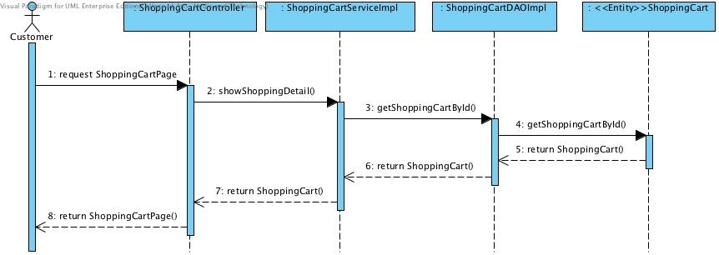

***SD-09: Customer can save shopping cart***

**ITC-**

Check the integration between

|  |  |
| --- | --- |
| **Test Case ID** |  |
| **Test Item(s)** |  |
| **Test Description** |  |
| **Expect Output** |  |
| **Actual Output** |  |

**URS-10: Customer remove product from shopping cart**

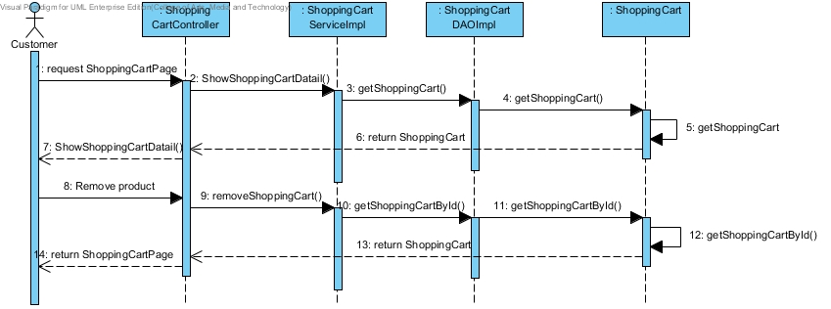

***URS-10: Customer remove product from shopping cart***

**ITC-**

Check the integration between

|  |  |
| --- | --- |
| **Test Case ID** |  |
| **Test Item(s)** |  |
| **Test Description** |  |
| **Expect Output** |  |
| **Actual Output** |  |

**URS-11: Customer select payment option**

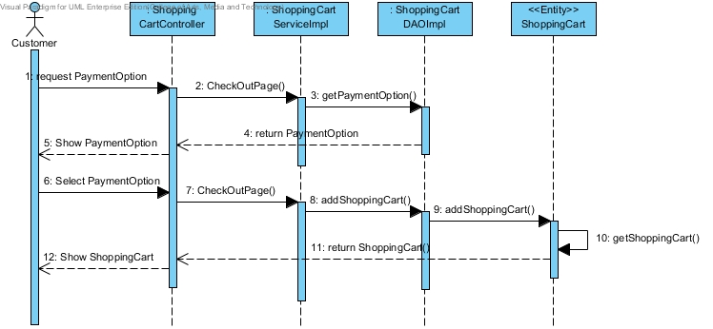

***SD-11: Customer select payment option***

**ITC-**

Check the integration between

|  |  |
| --- | --- |
| **Test Case ID** |  |
| **Test Item(s)** |  |
| **Test Description** |  |
| **Expect Output** |  |
| **Actual Output** |  |

**URS-12: Customer checkout product**

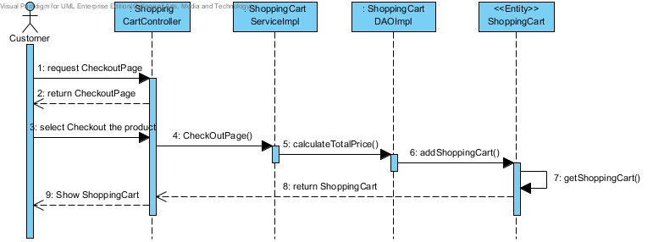

***SD-12: Customer checkout product***

**ITC-**

Check the integration between

|  |  |
| --- | --- |
| **Test Case ID** |  |
| **Test Item(s)** |  |
| **Test Description** |  |
| **Expect Output** |  |
| **Actual Output** |  |

**URS-13: Customer view shopping history**

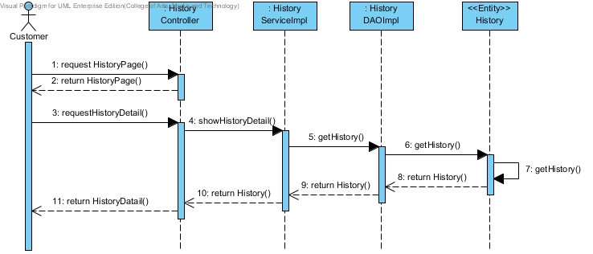

***URS-13: Customer view shopping history***

**ITC-**

Check the integration between

|  |  |
| --- | --- |
| **Test Case ID** |  |
| **Test Item(s)** |  |
| **Test Description** |  |
| **Expect Output** |  |
| **Actual Output** |  |

**SD-14: Customer logout from system**

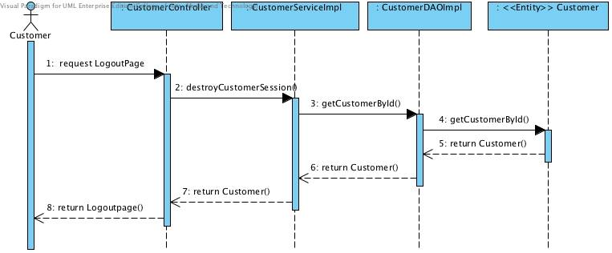

***SD-14: Customer logout from system***

**ITC-**

Check the integration between

|  |  |
| --- | --- |
| **Test Case ID** |  |
| **Test Item(s)** |  |
| **Test Description** |  |
| **Expect Output** |  |
| **Actual Output** |  |

**URS-15: Administrator login to the system**

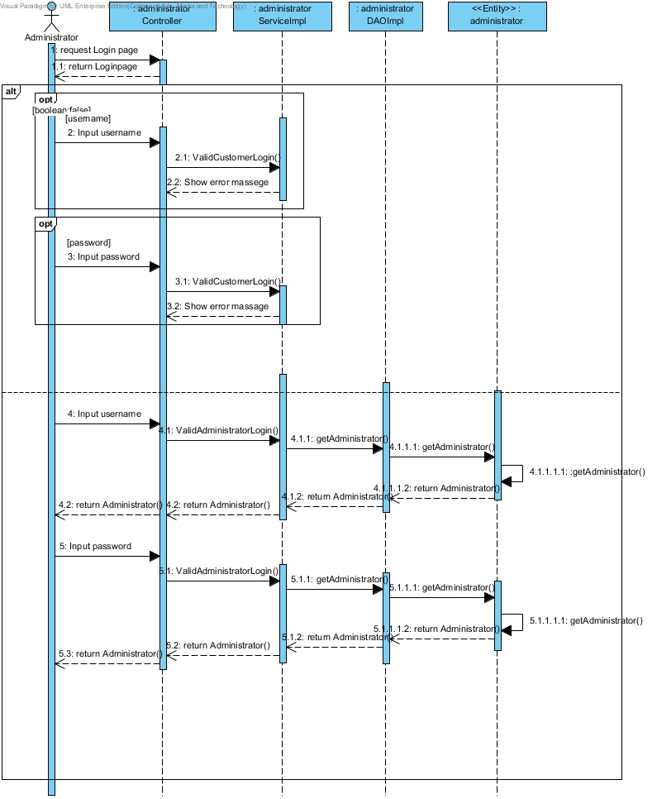

***URS-15: Administrator login to the system***

**URS-16: Administrator provide details of product**

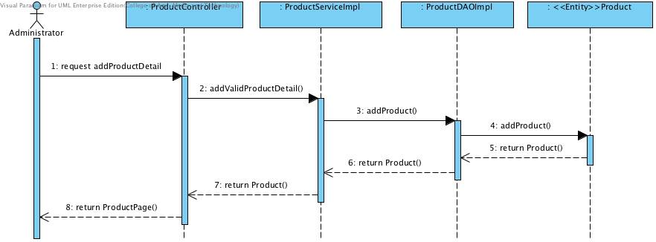

***SD-16: Administrator provide details of product***

**ITC-**

Check the integration between

|  |  |
| --- | --- |
| **Test Case ID** |  |
| **Test Item(s)** |  |
| **Test Description** |  |
| **Expect Output** |  |
| **Actual Output** |  |

**URS-17: Administrator view shopping history of all customers**

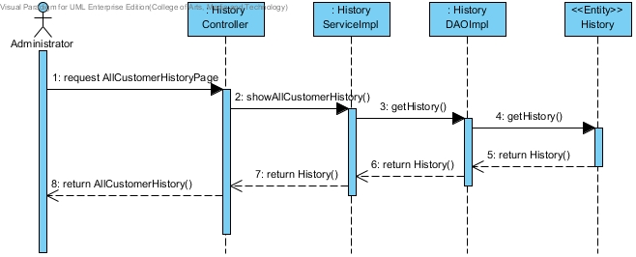

***URS-17: Administrator view shopping history of all customers***

**ITC-**

Check the integration between

|  |  |
| --- | --- |
| **Test Case ID** |  |
| **Test Item(s)** |  |
| **Test Description** |  |
| **Expect Output** |  |
| **Actual Output** |  |

**URS-18: Administrator logout from system**

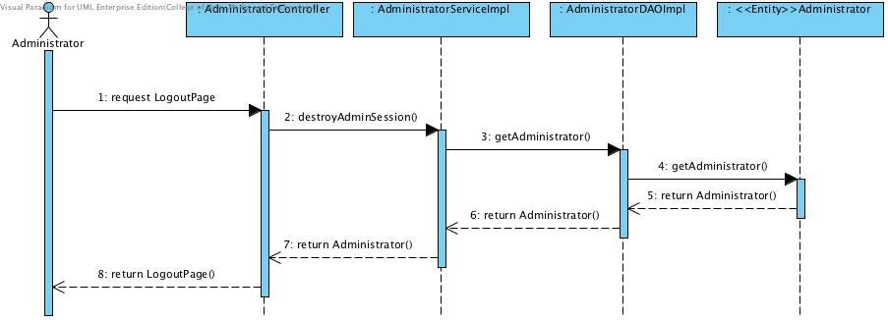

***URS-18: Administrator logout from system***

**ITC-**

Check the integration between

|  |  |
| --- | --- |
| **Test Case ID** |  |
| **Test Item(s)** |  |
| **Test Description** |  |
| **Expect Output** |  |
| **Actual Output** |  |